**Project -2**

**Creating Ads in Google**

**Lotus Fashion Studio:-**

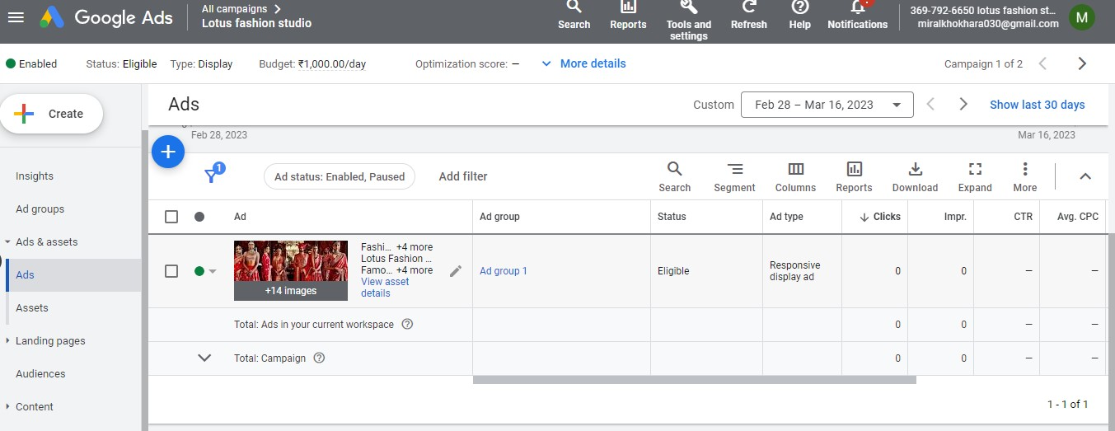

**LINK:-**

[**https://ads.google.com/aw_cm/ExternalPreview?hl=en_US&ad=651583230853&adGroup=149610557920&ocid=1193716705&isObfuscatedOcid=false&showMulPreview=true&showVariations=true&creativeType=35&pk=ACMAqCdf6sIEoPCqqOIgGvBBdfubpynhMhQstv58e9E6upC0XXs-ygfF2SmOpHLyR7-aoJwWWCiPNcInFzuH7jeWoxEX5DLZ7_L5pJbu2p3Zjw3_IpK0Cj_XZep9yQeRGznZ3B9A3aBCRJZbCoMqH0ikSWneO-9syj2wGlt_1bkLSS4WcIqyt0sDR0E**](https://ads.google.com/aw_cm/ExternalPreview?hl=en_US&ad=651583230853&adGroup=149610557920&ocid=1193716705&isObfuscatedOcid=false&showMulPreview=true&showVariations=true&creativeType=35&pk=ACMAqCdf6sIEoPCqqOIgGvBBdfubpynhMhQstv58e9E6upC0XXs-ygfF2SmOpHLyR7-aoJwWWCiPNcInFzuH7jeWoxEX5DLZ7_L5pJbu2p3Zjw3_IpK0Cj_XZep9yQeRGznZ3B9A3aBCRJZbCoMqH0ikSWneO-9syj2wGlt_1bkLSS4WcIqyt0sDR0E)**.**